**Exploratory Testing Report for buffalo burger** **Web** **Application**

**Date and Time:** September 4, 2024, 10:00 AM - 1:00 PM

**Tester(s):** Mohamed Mamdouh El Nomrosy (Junior QA Tester)

**Duration:** 3 hours

**Test Environment:**

* **Environment Details:**
  + Browser: Google Chrome Version🡺128.0.0.0
  + Operating System: Windows 10
  + Buffalo Burger Web Application
  + Network: Wi-Fi, Mobile Data
* **Tools Used:**
  + Browser Developer Tools
  + Screen Recording Software

**Testing Objectives:**

* **Scope:**
  + User login functionality
  + Product search and filtering
  + Checkout process
* **Focus:**
  + Usability and responsiveness of critical user flows
  + Validation of edge cases and error handling

**Test Approach:**

* **Exploration Strategy:**
  + Conducted user scenario-based testing focusing on common workflows and edge cases.
  + Performed random exploratory actions to uncover potential issues.
* **Techniques Used:**
  + Boundary value analysis for form inputs
  + Error guessing during the checkout process
  + Black Box end to-end Testing for UI

**Findings:**

* **Summary of Issues:**
  + **Issue 1:** Toggle Button
    - **Description:** The "Toggle Button" when you minimize screen from landscape and click on this button the button work correctly but when you maximize the window to landscape again the toggle button don’t be shown as the window be maximize before you click on it.
    - **Severity:** Low
    - **Reproduction Steps:**
      1. Navigate to the home page.
      2. Minimize the window screen.
      3. Click on the "Toggle Button".
      4. Maximize the window screen.
      5. "toggle button" don’t come back as shown on landscape screen it still shown as in minimize screen.
    - **Screenshots/Attachments:**

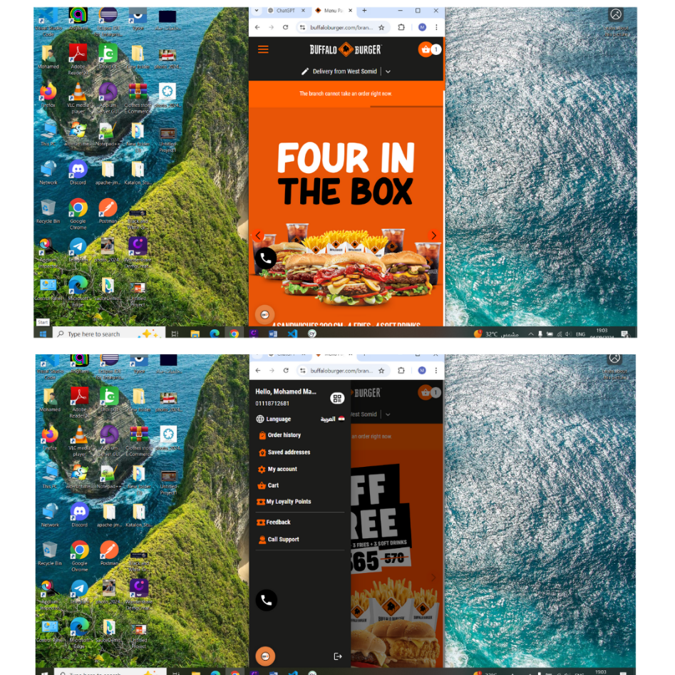

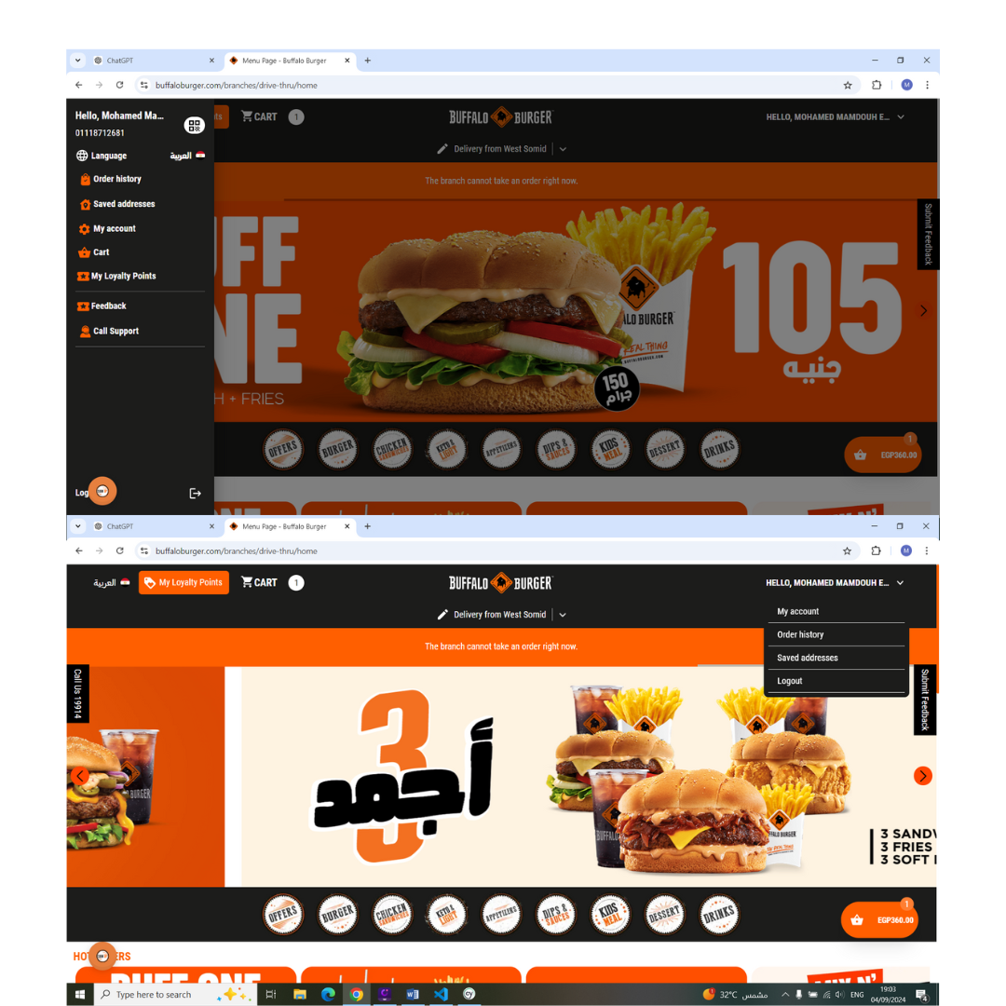

* + **Issue 2:** Shopping Cart Button
    - **Description:** The "Shopping Cart Button" when you minimize screen from landscape and click on this button the button work correctly but the item price doesn’t be shown beside it and when you maximize the window to landscape again the item price shown beside.
    - **Severity:** High
    - **Reproduction Steps:**
      1. Navigate to the home page.
      2. Minimize the window screen.
      3. Click on the "Shopping Cart Button".
      4. the item price doesn’t show beside it.
      5. Maximize the window screen.
      6. the item price shown beside it.
    - **Screenshots/Attachments:**

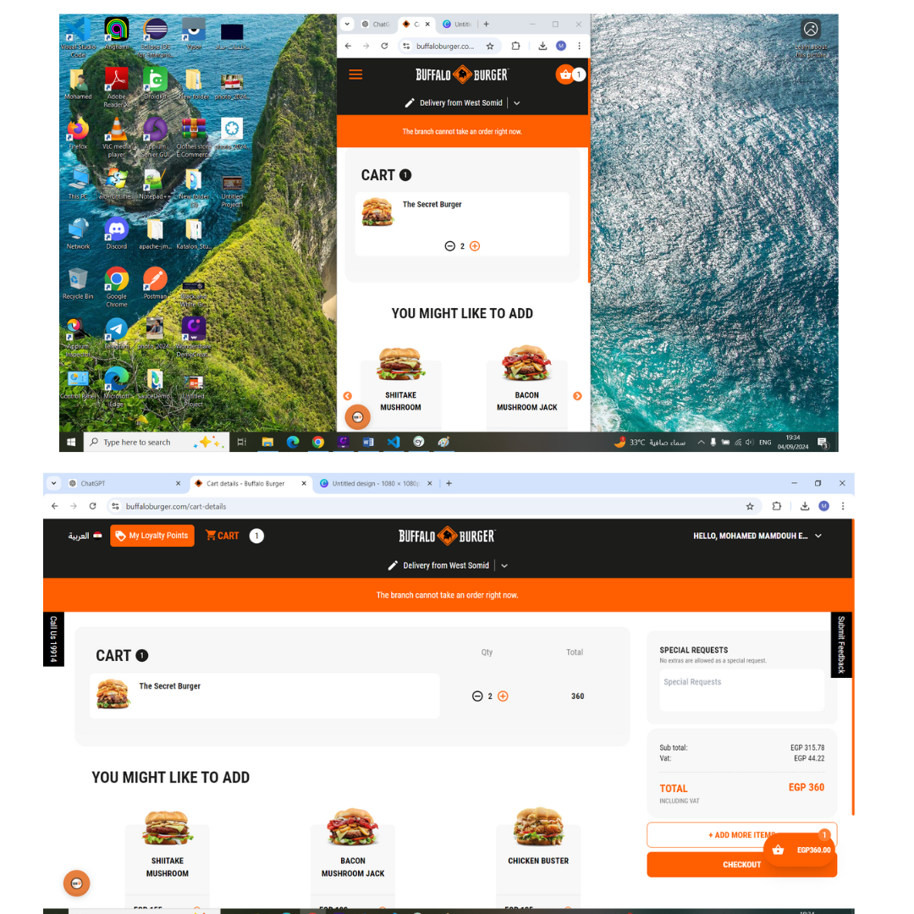

**Coverage and Gaps:**

* **Areas Covered:**
  + User registration
  + Product search and filtering
  + Checkout process
  + Responsivity
* **Coverage Gaps:**
  + Responsivity of Shopping Cart & Toggle Button processes
* **Recommendation:**
  + It is recommended to address the issue where the "Toggle Button" fails to reappear correctly after maximizing the window from a minimized state. Ensure that the button's visibility and state are properly adjusted and refreshed when transitioning between landscape and minimized views. This may involve checking the button’s rendering logic or its responsive behavior to ensure it consistently displays correctly in all screen states.
  + It is recommended to investigate and resolve the issue where the "Shopping Cart Button" behaves correctly when the screen is minimized from landscape mode, but the item price is not displayed beside it until the window is maximized back to landscape mode. Ensure that the item price is consistently visible and correctly updated beside the button regardless of the window's state. This may involve checking the responsive design implementation or the dynamic content rendering for the button to ensure proper display across different screen sizes.

**Conclusion:**

* **Summary:**
  + The exploratory testing session revealed minor and issues that need immediate attention. Overall, the core functionalities are mostly intact but require refinement in specific areas.
* **Overall Assessment:**
  + The application demonstrates good usability in most areas, but minor issues were observed specifically with responsiveness. Addressing these issues is essential to ensure a smooth user experience.